AI ASSISTED CODING – END SEMESTER LAB EXAM
Programme: B.Tech – CS & AI
Duration: 2 Hours
NAME : N.PRUDHVI ROLL NO :2403A510G7
BATCH – CSB06 DATE :24.11.25
Subset 12 – Backend API Development

Q1:Create course REST API
• Task 1: Use AI to scaffold endpoints.
• Task 2: Add JWT authentication

Prompt:
Build a Node.js Express Course API with CRUD.
JWT auth for POST/PUT/DELETE.
Include /auth/register and /auth/login.
Use in-memory data and error handling.
All code in a single file.

Code:
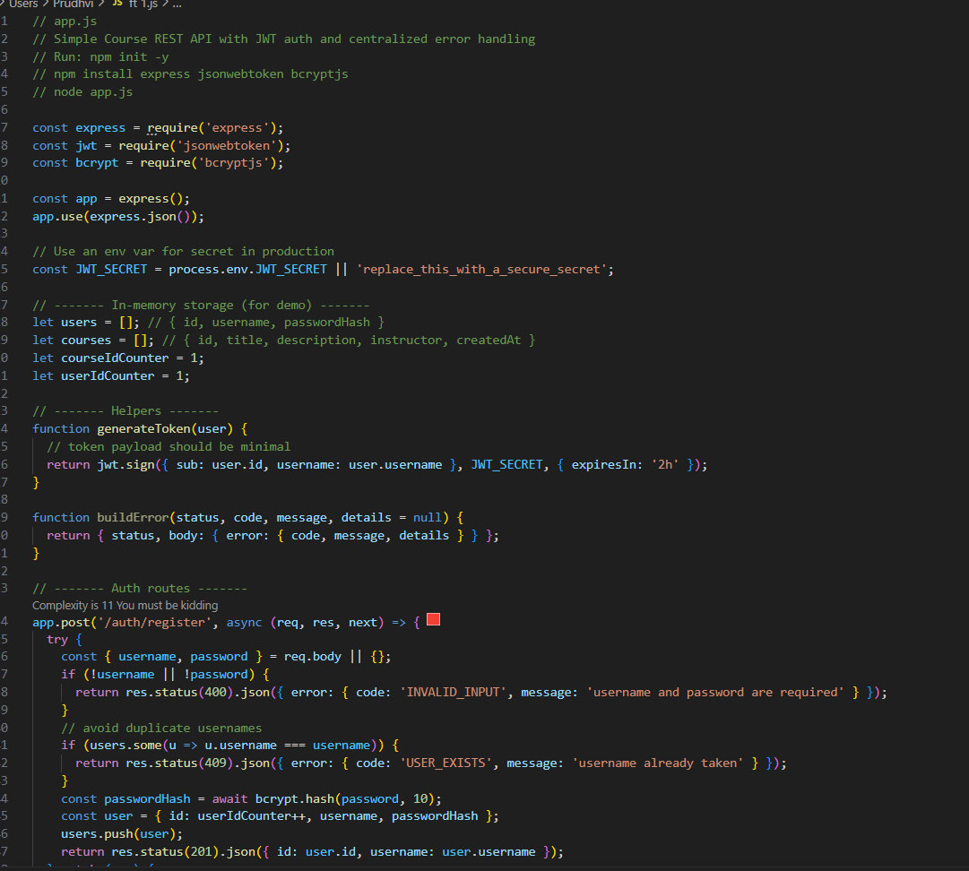
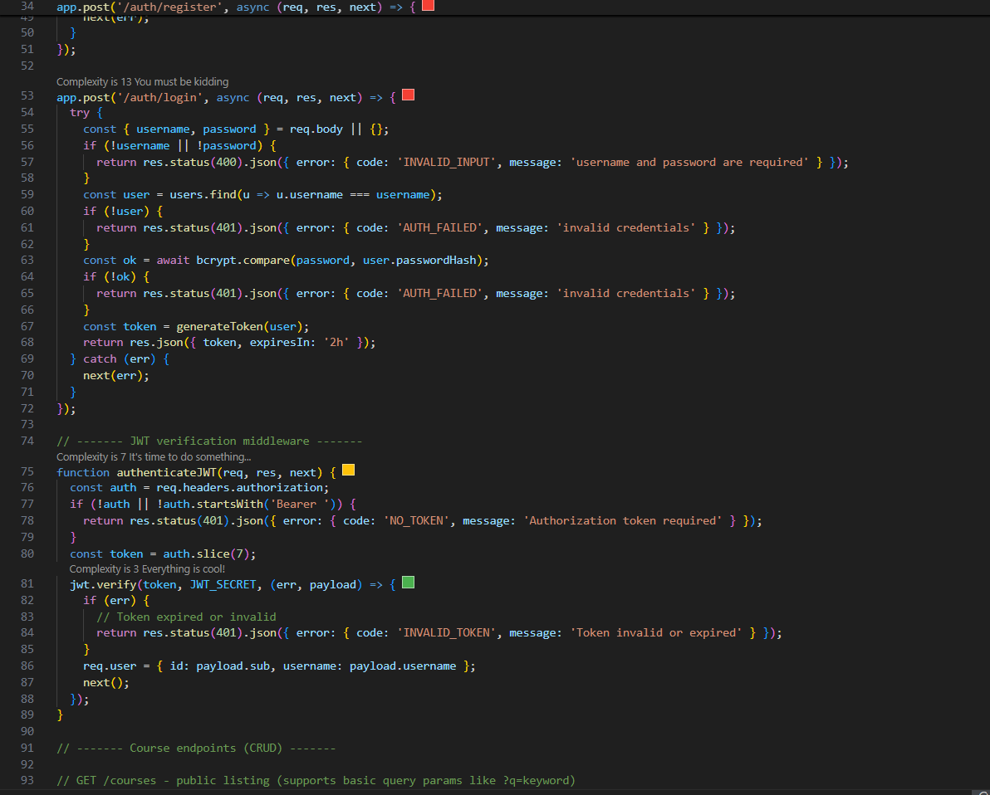
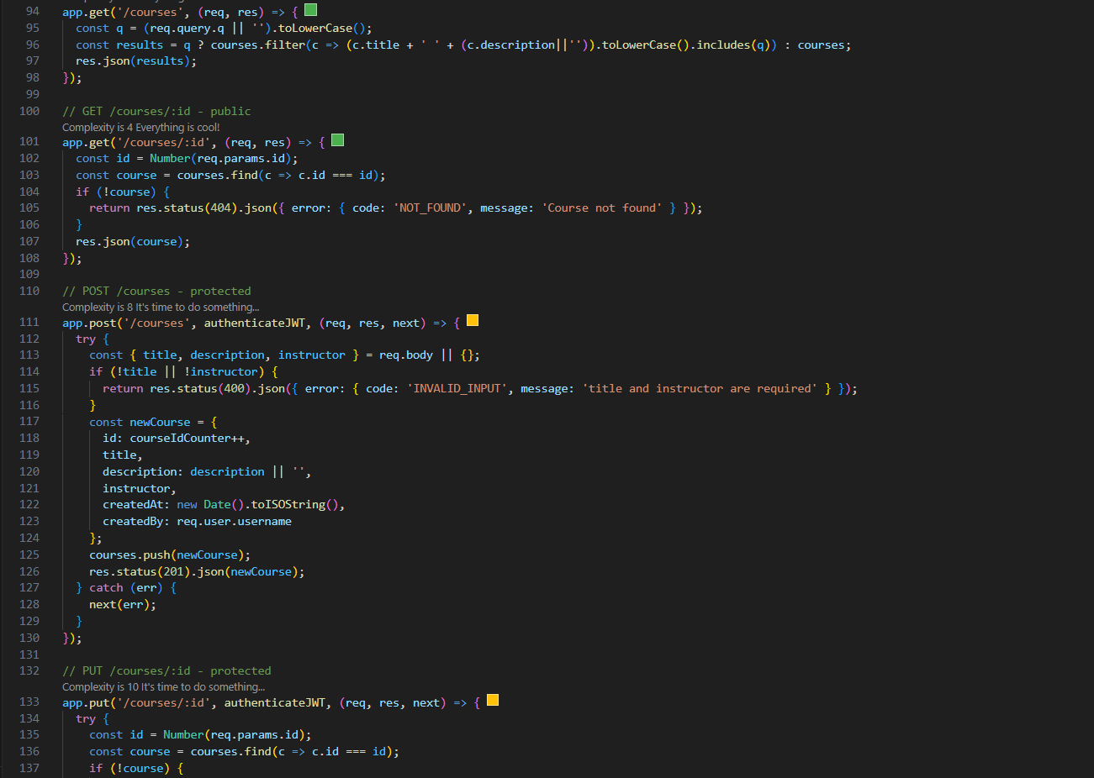
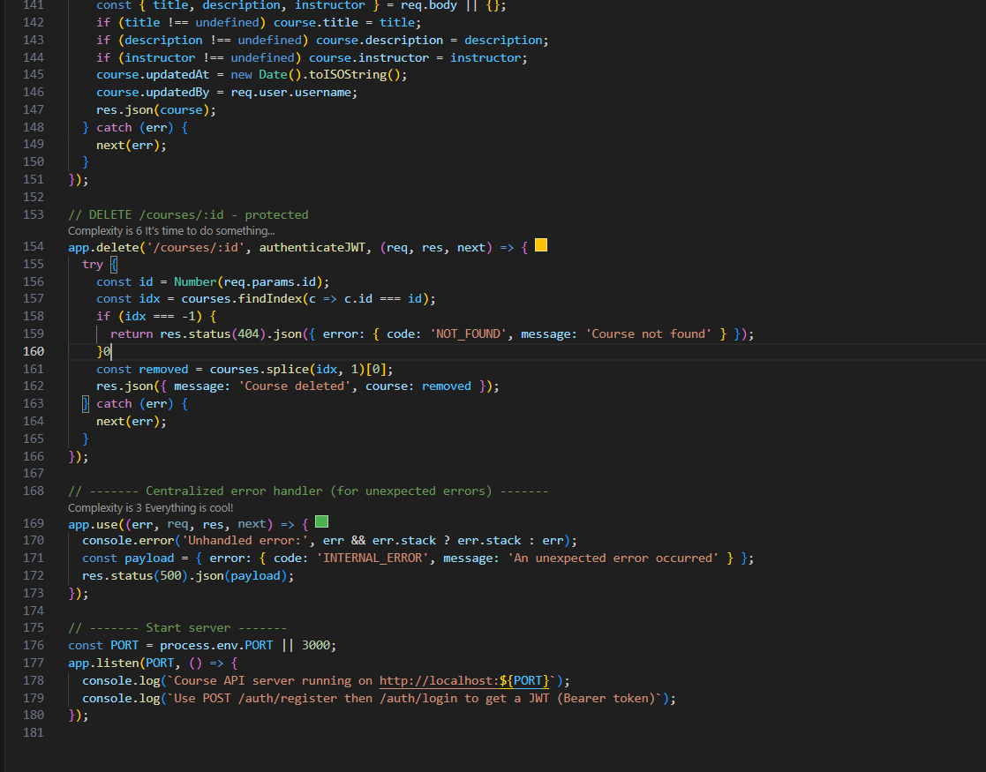

Output:
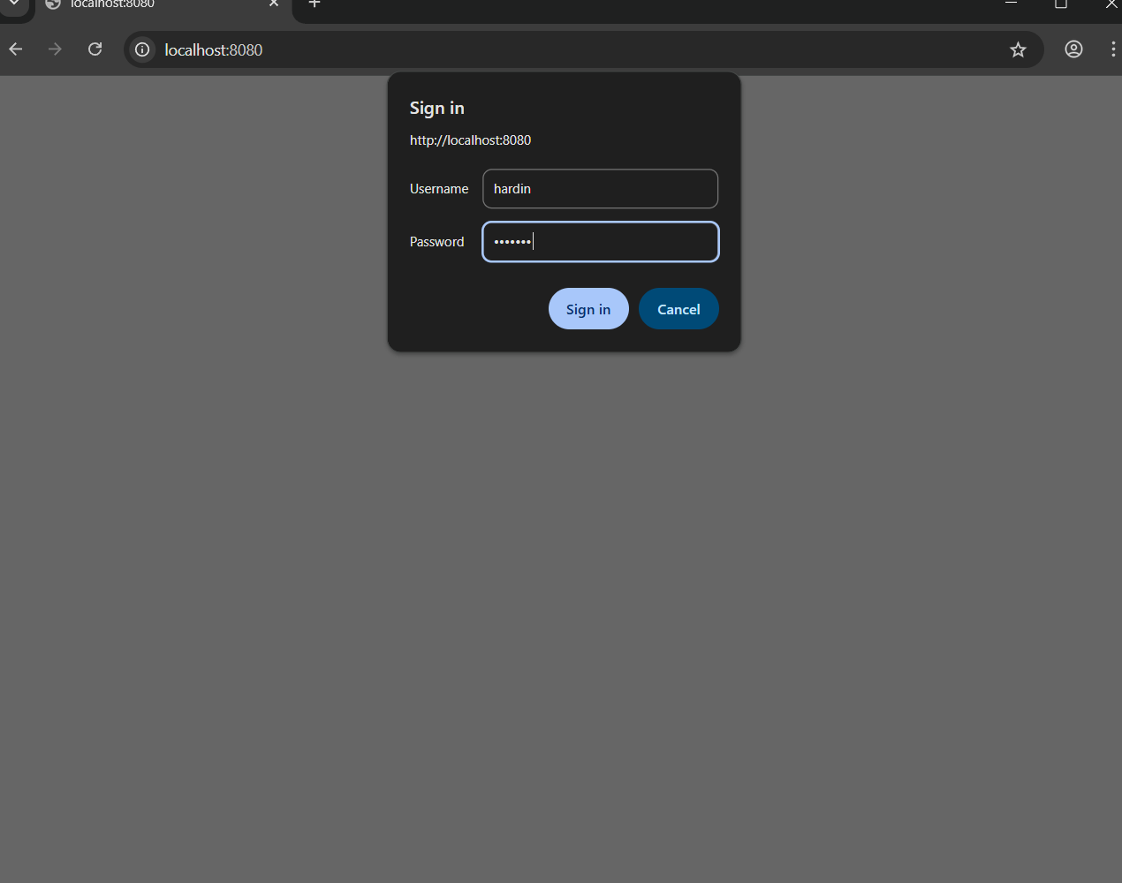

Observations:

. The scaffold provides a minimal but complete flow: register → login → protected CRUD endpoints. Good for demos and for iterating quickly.

. In-memory storage is ideal for scaffolding but must be replaced with a persistent DB (Mongo/Postgres) and an ORM/ODM in production; add migrations and connection retries.

. JWTs are stateless and simple; for user revocation or role-based access, consider refresh tokens, token blacklisting, or short token TTLs plus refresh tokens.

Q2. Error handling
• Task 1: AI identifies failure cases.
• Task 2: Implement proper responses

Prompt:

List main API failure cases and proper HTTP codes.

Provide unified JSON error format + central error handler.

Code:
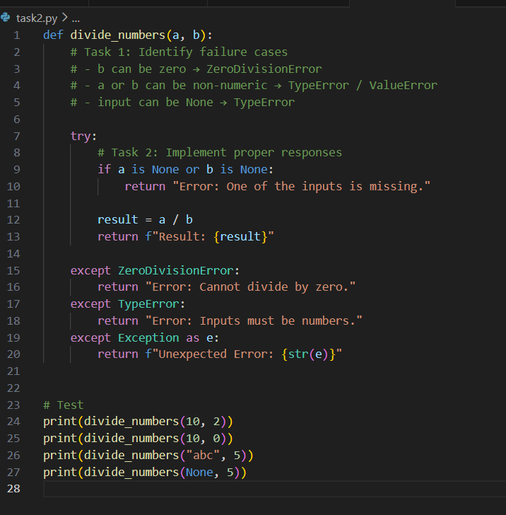
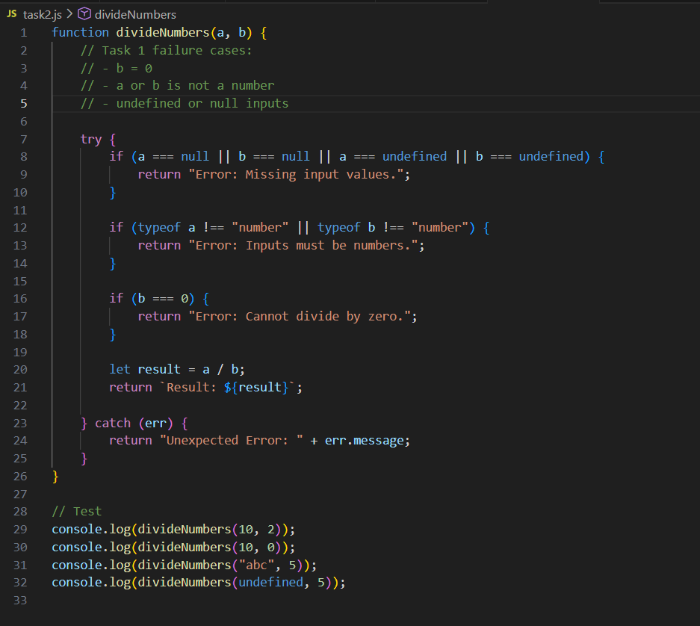

Output:


Observation:

Centralized error shapes make client-side handling predictable. Use consistent error.code strings and HTTP status codes.

Distinguish between client errors (4xx) and server errors (5xx). Log full stack traces server-side but return sanitized messages to clients.

Add request validation (e.g., Joi/zod/express-validator), rate limiting, and structured logging (json). For concurrency, use optimistic locking or DB transactions.

